**Sanjivani College of Engineering,**

**Department of Computer Engineering.**

**DATABASE MANAGEMENT SYSTEM LABORATORY.**

* Name: Nikita Rajendra Bhawar
* Class: SY A
* Roll No.:18
* PRN No. : UCS21F1018
* Assignment No.:4
* **Problem statement:-**

Cursors: (All types: Implicit, Explicit, Cursor FOR Loop, Parameterized Cursor) Write a PL/SQL block of code using parameterized Cursor, that will merge the data available in the newly created table N_RollCall with the data available in the table O_RollCall. If the data in the first table already exist in the second table then that data should be skipped. Frame the separate problem statement for writing PL/SQL block to implement all types of Cursors inline with above statement. The problem statement should clearly state the requirements

* **To create Database cursor:-**

create database assi7;

use assi7;

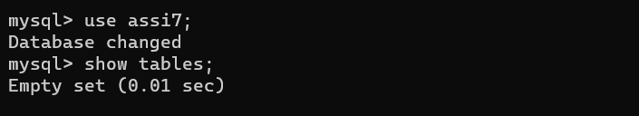show tables;

* **Create table old_roll and new_roll and insert values in it:-**

create table old_roll(roll int,name varchar(10));

create table new_roll(roll int,name varchar(10));

insert into old_roll values(4,'d');

insert into old_roll values(3,'bcd');

insert into old_roll values(1,'bc');

insert into old_roll values(5,'bch');

insert into new_roll values(2,'b');

insert into new_roll values(5,'bch');

insert into new_roll values(1,'bc');

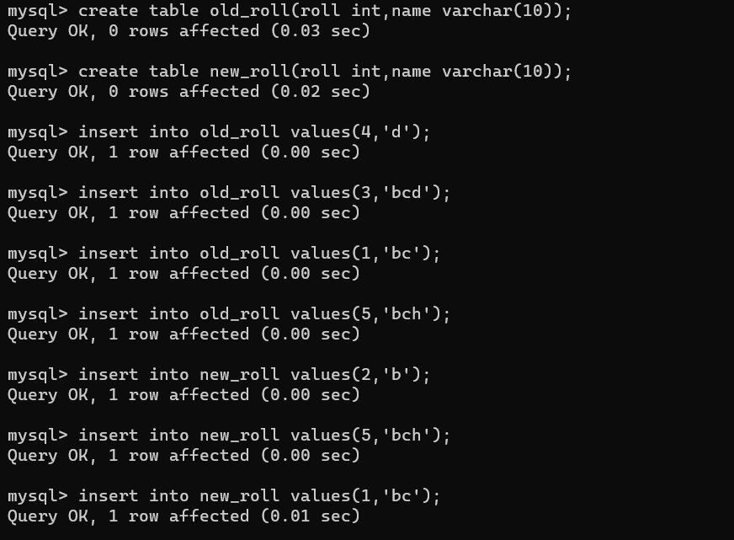

* **To display old_roll and new_roll:-**

select * from old_roll;

select * from new_roll;

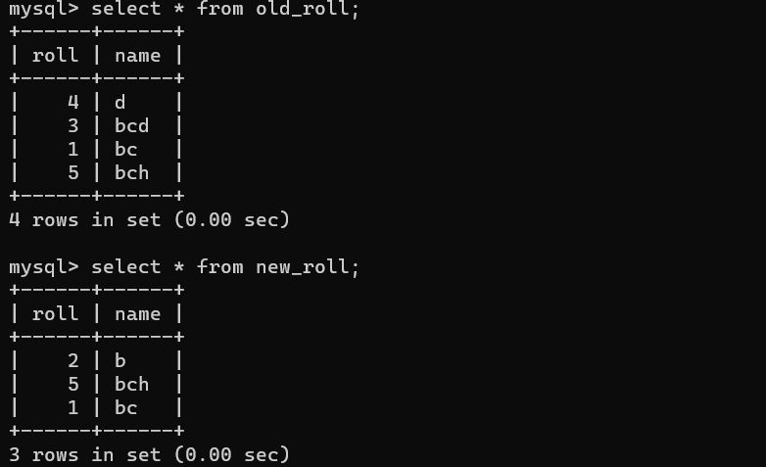

delimiter $

create procedure roll_list()

begin

declare oldrollnumber int;

declare oldname varchar(10);

declare newrollnumber int;

declare newname varchar(10);

declare done int default false;

declare c1 cursor for select roll,name from old_roll;

declare c2 cursor for select roll,name from new_roll;

declare continue handler for not found set done=true;

open c1;

loop1:loop

fetch c1 into oldrollnumber,oldname;

if done then

leave loop1;

end if;

open c2;

loop2:loop

fetch c2 into newrollnumber,newname;

if done then

insert into new_roll values(oldrollnumber,oldname);

set done=false;

close c2;

leave loop2;

end if;

if oldrollnumber=newrollnumber then

leave loop2;

end if;

end loop;

end loop;

close c1;

end $

delimiter ;

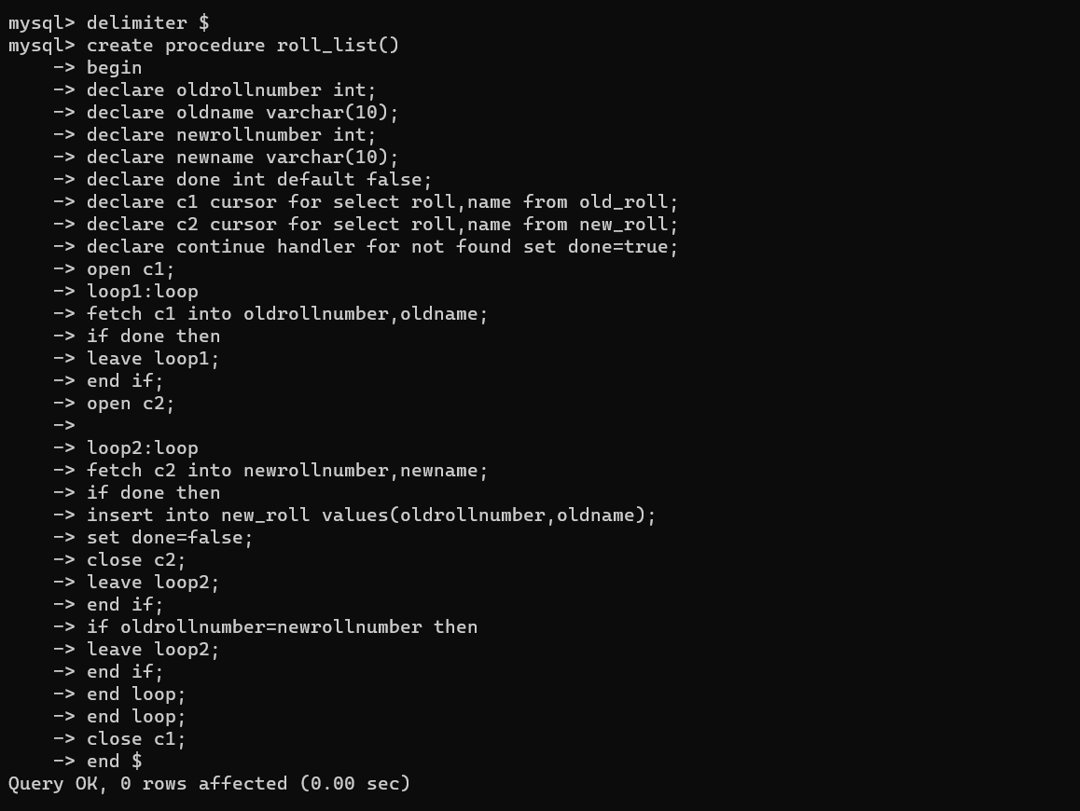

call roll_list();

select * from new_roll;

